Question 1
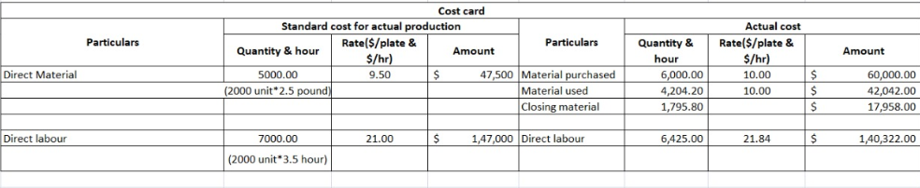

1) Direct material price variance = (standard rate –actual rate) x actual quantity purchased.
($9.5-$10) x 6000 pounds =$-3000(unfavorable)
Direct material price variance =$-3000 unfavorable

2) Direct material quantity variance = (standard quantity –actual quantity used) standard rate
(5000 pounds -4204.2 pounds) x $9.5=$7560.1 favorable
Direct material quantity variance=$7560.1 favorable.

3) Direct labor rate variance = (standard rate-actual rate) x Actual hours
($21/hr-$21.84/hr) x 6425hrs= -5397 unfavorable
Direct labor rate variance =-5397 unfavorable

4) Direct labor efficiency variance = (standard hrs-actual hrs) x standard rate
(7000hrs -6425 hrs) x $21/hr =$ 12075 favorable.
Direct labor efficiency variance = 12075 favorable
.
5) Direct material purchase price variance= (standard rate –actual rate) x actual materials purchased.
($9.5-$10) x 6000 pounds =$-3000(unfavorable)
Direct material purchase price variance =$-3000 unfavorable

